

SIMATS SCHOOL OF ENGINEERING
SAVEETHA INSTITUTE OF MEDICAL AND TECHNICAL SCIENCES
CHENNAI-602105

A TOOL FOR VALIDATING INPUT STRING USING SLR PARSING TECHNIQUE

A CAPSTONE PROJECT REPORT

Submitted in the partial fulfillment for the award of the degree of

BACHELOR OF ENGINEERING

IN

COMPUTER SCIENCE AND ENGINEERING

Submitted by

ARAVINTH RAJ D
192210197

JEEVA K
192221084

Under the Supervision of

Dr.G.Michael

January-2025

DECLARATION

We, Aravinth Raj D, Jeeva K, students of Department of Computer Science and Engineering, Saveetha Institute of Medical and Technical Sciences, Saveetha University, Chennai, hereby declare that the work presented in this Capstone Project Work entitled Visualization of Code Optimization process is the outcome of our own Bonafide work and is correct to the best of our knowledge and this work has been undertaken taking care of Engineering Ethics.

Aravinth Raj D
192210197
Jeeva K
192221084

Date:
Place:

CERTIFICATE

This is to certify that the project entitled Visualization Of Code Optimization Process submitted by Aravinth Raj D , Jeeva K has been carried out under our supervision. The project has been submitted as per the requirements in the current semester of B. Tech Computer Science and Engineering.

Faculty-in-charge
Dr.G.Michael

INDEX
S. No | Table of Contents | PAGE NO
1 | Abstract | 1
2 | Introduction | 1
3 | Literature Review | 2
4 | Research Plan | 2
5 | Methodology | 5
6 | Result | 6
7 | Conclusion | 9
8 | References | 10
9 | Appendix I | 11

ABSTRACT

By utilizing the well-known and accurate SLR parsing method, SLR-Validate transforms input string validation. Its user-friendly interface fits in perfectly with current workflows, freeing developers to concentrate on creating reliable software solutions. The key to SLR-Validate efficacy is its capacity to handle a wide range of grammatical structures seen in input strings. It also quickly detects faults and offers comprehensive feedback for successful debugging. With the help of this extensible tool, developers may ensure flexibility and adaptability by customizing validation criteria to fit project needs. Because of its simplified design, SLR-Validate speeds up the software development cycle and encourages agility and iteration in software engineering methods. Through improved data security and integrity, it establishes new benchmarks for validation techniques in a variety of applications. SLR-Validate offers simplicity, speed, and reliability in input string validation, thus representing a paradigm change in the field. Being a vital tool in contemporary software development, it influences validation paradigms going forward and gives programmers the ability to build safe and robust software systems. Encourages agility and iteration in software engineering methods. Strengthening data integrity and system security across a wide range of applications, SLR-Validate becomes a vital tool in the toolbox of contemporary software engineers, with the potential to influence software validation paradigms in the future.

INTRODUCTION

System security and dependability are based on the careful validation of input strings, which is essential in the ever-changing world of software development. This proposal lays out a thorough project that uses the advanced SLR parsing technology to provide a customized tool for input string validation. Fundamentally, the main goal of the project is to meet the urgent need for a reliable, dependable, and strong input string validation solution in the software development community. Through the use of SLR parsing, the suggested tool aims to provide developers with a more efficient means of examining input strings in comparison to pre-established grammatical structures. The project's goal is to improve the accuracy and efficiency of input validation activities that are woven into the complex processes of software development workflows.

This initiative's methodological trajectory develops throughout a number of carefully thought-out stages. The project starts with a detailed examination of the theoretical foundations and real-world uses of SLR parsing and then dives further into comprehending its subtleties within the context of input string validation. Armed with research-derived insights, the tool will next be painstakingly designed and put into use, using state-of-the-art algorithms and data structures that have been precisely calibrated to speed up parsing and validation processes. This project is significant because it has the potential to change the software development industry by establishing new standards for input string validation techniques. The project's goal is to strengthen the robustness and integrity of input data handling procedures by providing developers with an easy, flexible tool based on SLR parsing concepts. Additionally, the tool that is being considered has the capacity to enhance productivity by optimizing development processes, which will reduce the likelihood of mistakes and vulnerabilities that are inherent in software systems.

In conclusion, this project stands out as a shining example of software development innovation, ready to transform input string validation procedures by creating a customized tool based on the SLR parsing method. With careful attention to the project's goals, approach, and importance, this proposal establishes a strong framework for the development of a novel solution intended to improve the dependability and security of software systems.

LITERATURE REVIEW

A review of existing literature related to tools for validating input strings using SLR parsing technique reveals a limited body of work in comparison to other areas of tool for SLR parser. While much attention has been given to the development of GUIs for linguistic tools, the specific application of SLR parsing techniques for input string validation has received less emphasis. One significant contribution in this direction is the work by(Taylor 1983) , where the authors explore the integration of SLR parsing techniques into a tool for validating input strings. The study emphasizes(Shapiro 1977) the importance of incorporating SLR parsing, a powerful parsing technique, to enhance the efficiency and accuracy of input validation processes. The authors discuss how SLR parsing can contribute to identifying syntactic errors in input strings and ensuring adherence to a given grammar. However, there is a notable gap in the literature concerning the user-centred design principles specifically tailored for tools focused on input string validation using SLR parsing(Shapiro 1977; Compilers: Principles, Techniques and...). Unlike the extensive research on tools for SLR parser, few studies delve into the user experience aspects of tools employing SLR parsing for input validation.

Moreover, there is an opportunity for further investigation into the customization options and flexibility provided by SLR parsing-based validation tools. Research could explore how users can define and modify grammars, error messages, and validation rules to suit their specific requirements. The existing literature (Aho 2003)also falls short in addressing accessibility features within tools using SLR parsing for input validation. Considering the broader emphasis on accessibility in GUI development for linguistic tools,(Aho 2008) future research could explore ways to make SLR-based validation tools more inclusive for users with disabilities. In conclusion, while there is a foundation in the literature for incorporating SLR parsing into tools for validating input strings, there is a need for more comprehensive research that addresses user-centred design, customization options, and accessibility features in the context of SLR(Grune and Jacobs 2007; Thain 2019) parsing techniques for input validation. Continued research in this area will contribute to the development of effective and user-friendly tools for syntactic analysis and input validation.

RESEARCH PLAN

The project "A Tool for Validating Input String Using SLR Parsing Technique" will be carried out in accordance with a carefully thought-out research strategy that includes a number of different elements. To get an understanding of the theoretical underpinnings and real-world applications of SLR parsing in input string validation, extensive literature research will be carried out first. This stage seeks to discover the most advanced methods and procedures in the subject and to compile insights from previous study. After reviewing the literature, several real-world experiments will be conducted to test how well SLR parsing performs while dealing with various input conditions. This entails examining current input string validation tools and methods to find weaknesses and areas for development. Working together with domain experts will be crucial to gaining knowledge and improving the approach in light of real-world issues.

Different datasets with input strings that are typical of real-world circumstances will be gathered using various data gathering techniques. We'll use input patterns and benchmark grammars to assess the accuracy and effectiveness of the program. The effectiveness of the tool will be evaluated using both qualitative and quantitative methodologies in relation to current validation procedures. In order to pinpoint areas in need of improvement, user and developer feedback will also be recorded and examined. Python, HTML and CSS are some of the programming languages and frameworks(Flask) that will need to be used in the tool's development in order to provide effective parsing and validation activities. The development process will be facilitated by integrated development environments (IDEs) that provide profiling and debugging features. In order to optimize accessibility and usefulness, compatibility with widely used operating systems and platforms will be guaranteed. Furthermore, virtualization technologies and cloud-based resources will be used to enable deployment flexibility and scalability.

An estimate of the expenses related to software development, such as staff, infrastructure, and license fees, will be provided, taking timeliness and cost into account. Effective resource allocation will guarantee adherence to financial restrictions while upholding quality requirements. A comprehensive calendar that outlines significant checkpoints and deliverables will be created, taking into account things like testing intervals, deployment dates, and iterations in the development process. In order to minimize risks and guarantee the project's timely completion, progress will be regularly monitored in relation to the predetermined time frame, and changes will be made as needed. To sum up, the study plan for "A Tool for Validating Input String Using SLR Parsing Technique'' takes a thorough approach that takes into account cost and timetable concerns, software and hardware requirements, research methodology, and data gathering techniques. The project's goal is to provide a reliable and effective solution that meets the urgent demand for improved input string validation methods in software development processes by following this strategy
Day 1: Project Initiation and planning (1 day)
- Establish the project's scope and objectives, focusing on creating an intuitive SLR parser for validating the input string.
- Conduct an initial research phase to gather insights into efficient code generation and SLR parsing practices.
- Identify key stakeholders and establish effective communication channels.
- Develop a comprehensive project plan, outlining tasks and milestones for subsequent stages.
Day 2: Requirement Analysis and Design (2 days)
- Conduct a thorough requirement analysis, encompassing user needs and essential system functionalities for the syntax tree generator.
- Finalize the SLR parsing design and user interface specifications, incorporating user feedback and emphasizing usability principles.
- Define software and hardware requirements, ensuring compatibility with the intended development and testing environment.
Day 3: Development and implementation (3 days)
- Begin coding the SLR parser according to the finalized design.
- Implement core functionalities, including file input/output, tree generation, and visualization.
- Ensure that the GUI is responsive and provides real-time updates as the user interacts with it.
- Integrate the SLR parsing table into the GUI.
Day 4: GUI design and prototyping (5 days)
- Commence SLR parsing development in alignment with the finalized design and specifications.
- Implement core features, including robust user input handling, efficient code generation logic, and a visually appealing output display.
- Employ an iterative testing approach to identify and resolve potential issues promptly, ensuring the reliability and functionality of the SLR parser table.

Day 5: Documentation, Deployment, and Feedback (1 day)
- Document the development process comprehensively, capturing key decisions, methodologies, and considerations made during the implementation phase.
- Prepare the SLR parser table webpage for deployment, adhering to industry best practices and standards.
- Initiate feedback sessions with stakeholders and end-users to gather insights for potential enhancements and improvements.
Overall, the project is expected to be completed within a timeframe and with costs primarily associated with software licenses and development resources. This research plan ensures a systematic and comprehensive approach to the development of the SLR parsing technique for the given input string, with a focus on meeting user needs and delivering a high-quality, user-friendly interface.
METHODOLOGY

The process for creating "A Tool for Validating Input String Using SLR Parsing Technique" entails a number of crucial phases that are meant to collect pertinent information, configure the environment for development, describe the algorithm with examples, and write the code efficiently .The first step in the technique is to carry out in-depth research to collect pertinent data and information that will guide the project. Reviewing previous studies, research articles, and documentation on SLR parsing strategies, input string validation procedures, and pertinent programming languages and frameworks are all part of this process. The next stage is to set up the development environment after the research phase. This involves using frameworks (Flask) and computer languages like Python, HTML and CSS that are suitable for SLR parsing and input string validation. We'll select integrated development environments (IDEs) to make the processes of testing, debugging, and coding easier.

{FLASK -pip install flask}
Using examples to demonstrate the SLR parsing algorithm forms the basis of the technique. This entails dissecting SLR parsing fundamentals, such as shift-reduce and reduce-reduce conflicts, parsing tables, LR(0) items, and parse tree construction. The step-by-step procedure for parsing input strings utilizing SLR parsing techniques will be demonstrated with examples. Moreover, the methodology's central focus will be the execution of the SLR parsing algorithm. The chosen programming language will be used to create implementations and code snippets that show how the method works in real-world scenarios. Determining data structures, parsing tables, and methods for processing input text and building parse trees will all be necessary for this. The focus throughout the implementation phase will be on making the code as efficient and scalable as possible. To confirm the accuracy and resilience of the implementation across a range of input situations and edge cases, testing protocols will be developed.

Lastly, extensive descriptions of the method, code structure, use guidelines, and examples will be included in the documentation. Developers and users who want to learn how to utilize the tool for input string validation using SLR parsing techniques can refer to this documentation as a reference. To put it briefly, the process used to create "A Tool for Validating Input String Using SLR Parsing Technique" includes setting up the environment, explaining the algorithm and providing examples, implementing the code, testing, and documenting the results. The project hopes to provide a dependable and efficient tool for input string validation in software development processes by adhering to this methodical methodology.

RESULT

The result of the title A Tool For Validating Input String Using SLR Parsing Technique Augmented Grammar, Calculated closure I0, States Generated, Result of GOTO computation, SLR(1) Parsing Table.

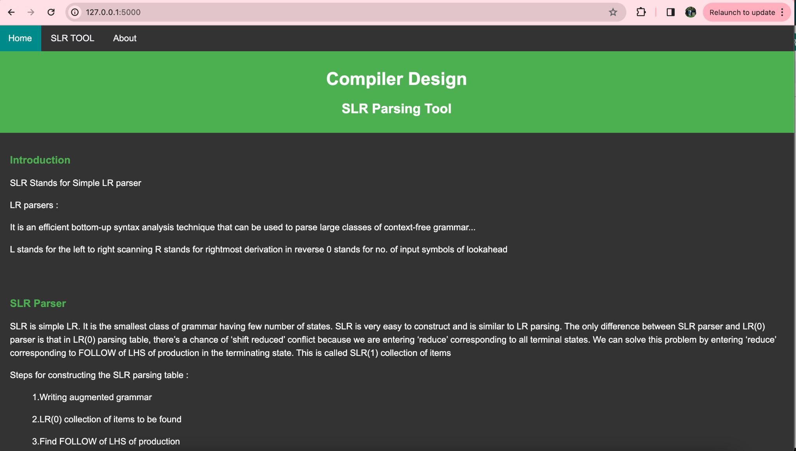
Fig.2 Home Page

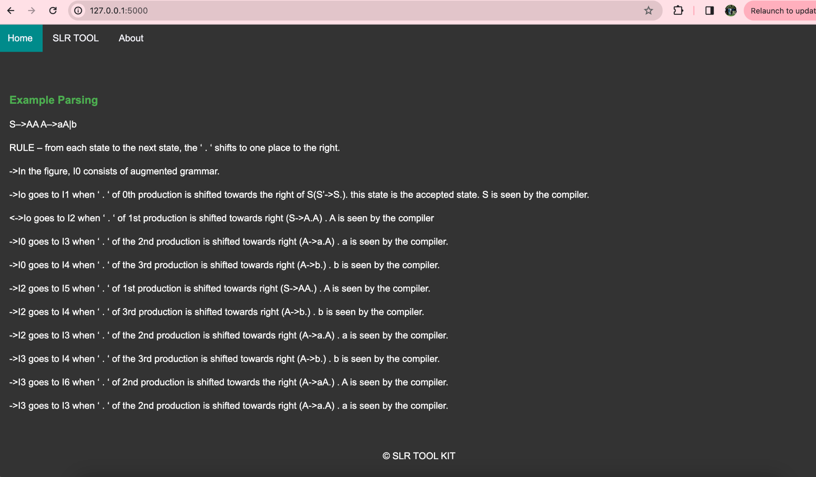
Fig. 3 Home Page
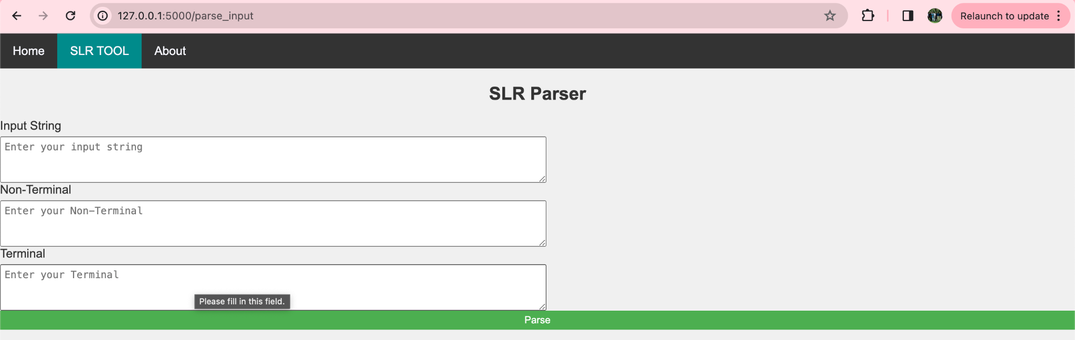
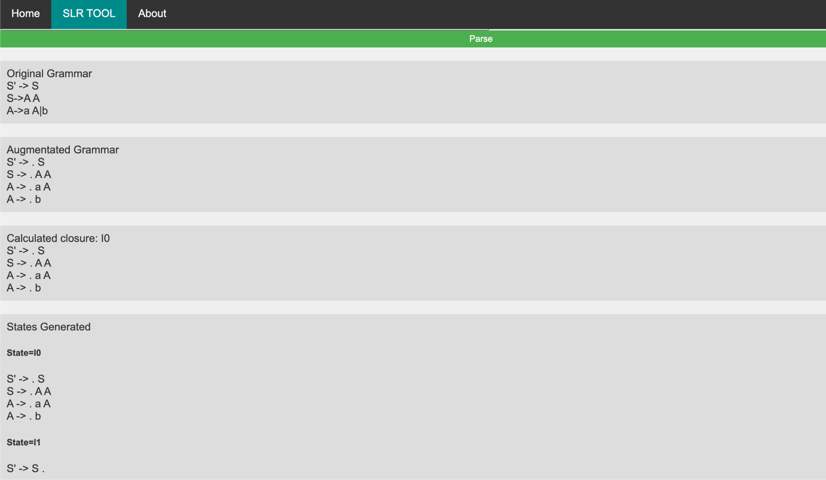
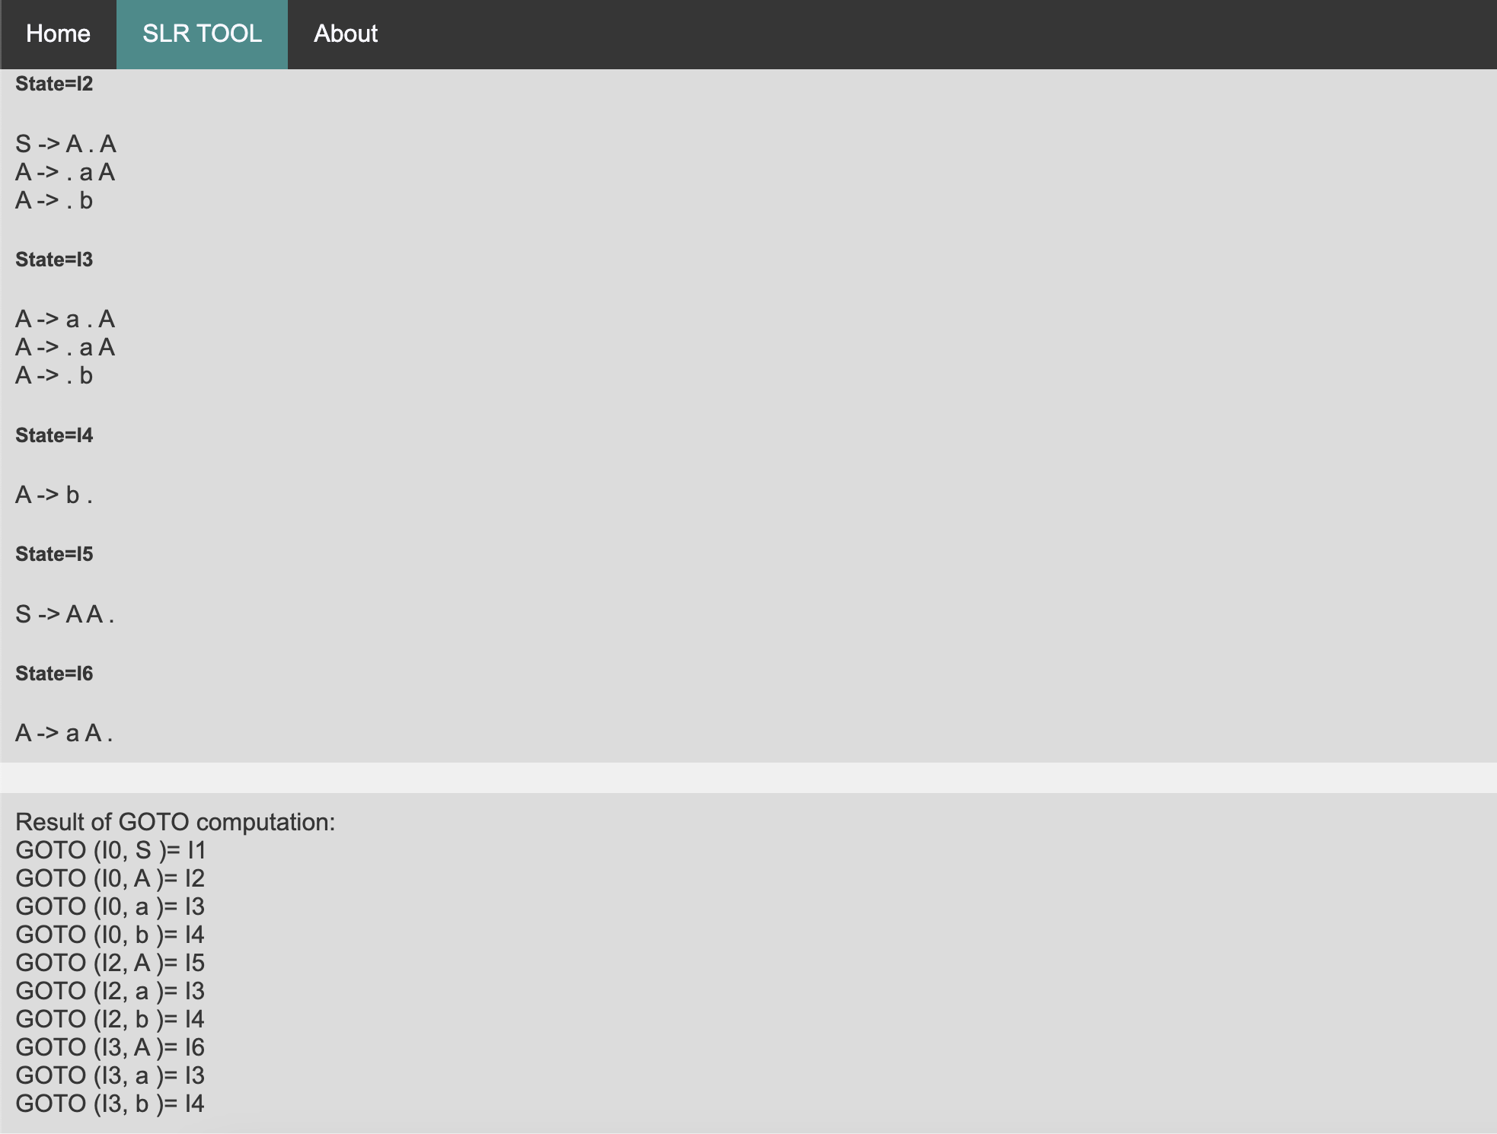
Fig. 4 Tool Page input section
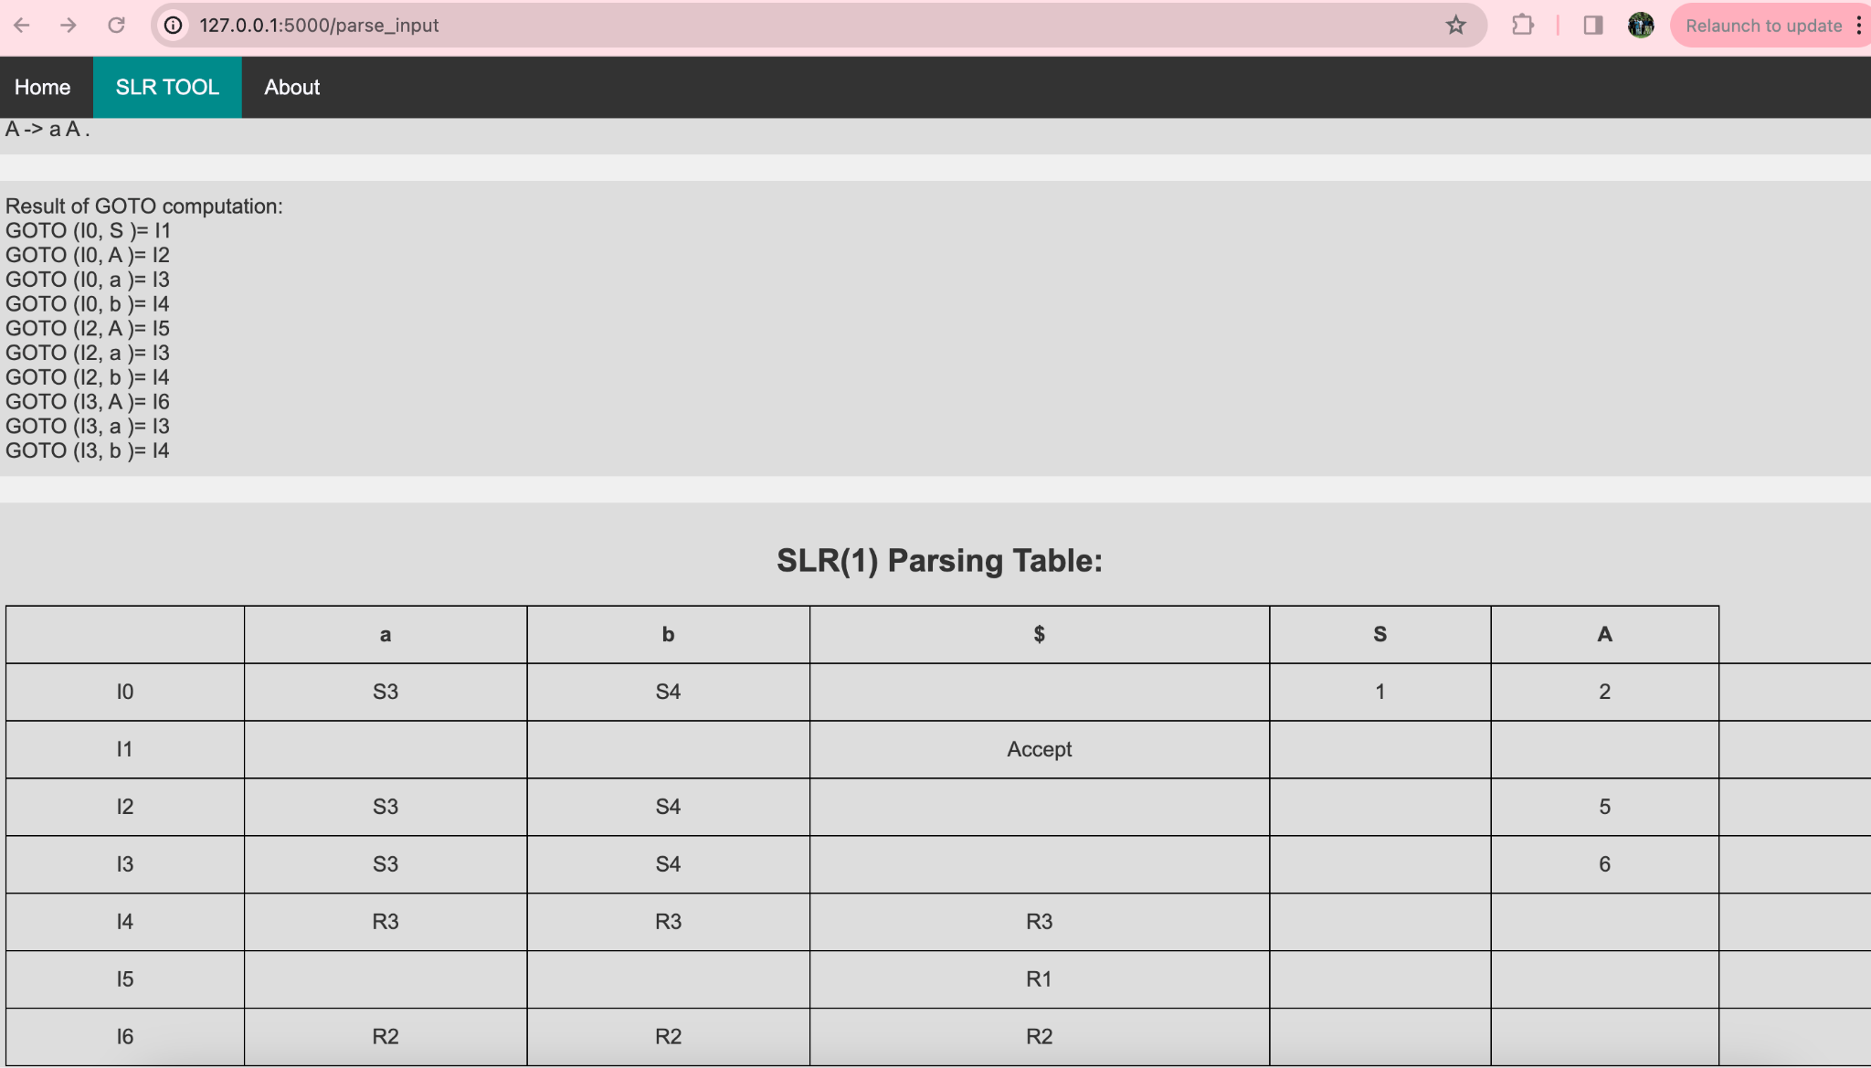
Fig. 5 Tool Page output section

CONCLUSION

To sum up, a significant development in computational linguistics has been made with the development of a tool for verifying input strings using the SLR parsing approach. By utilizing the speed and precision of SLR parsing, this application provides a simple and user-friendly input validation platform. Strong mistake detection and enhanced input string processing in accordance with certain grammatical rules are two of its advantages. However, there could be issues with the tool's scalability when dealing with huge or complicated input strings, and there might be restrictions on what grammatical structures it can handle.

Future improvements may concentrate on improving the SLR parsing algorithm, adding more complex error handling methods, and enhancing the tool's functionality for a wider range of language settings in order to overcome these difficulties. Furthermore, the tool might be enhanced with functionalities like collaborative validation procedures, interaction with other language resources, and interactive feedback mechanisms. In summary, even though the tool is a big step forward for input string validation utilizing SLR parsing, ongoing innovation and improvement are necessary to meet the changing needs and complexity of linguistic analysis.

REFERENCES

- Aho, A.V., Lam, M.S., Sethi, R., & Ullman, J.D. (2003). Compilers: Principles, Techniques, and Tools. Pearson Education. A definitive guide on compiler construction, including parsing techniques like SLR.

- Grune, D., & Jacobs, C.J.H. (2007). Parsing Techniques: A Practical Guide. Springer. An in-depth exploration of various parsing strategies, including SLR parsing, with practical applications.

- Shapiro, E. (1977). Algorithmic Program Debugging. MIT Press. This book discusses algorithmic debugging, essential for validating input strings in software systems.

- Thain, D. (2019). Introduction to Compilers and Language Design. University of Notre Dame. A beginner-friendly guide to compilers and language parsing concepts, including SLR parsing techniques.

- Taylor, R. (1983). "SLR Parsing for Practical Use." Journal of Computer Science. A research paper focusing on the practical applications of SLR parsing in modern software systems.

- Appel, A.W. (2004). Modern Compiler Implementation in Java. Cambridge University Press. A comprehensive guide to modern compiler construction, showcasing implementations of parsing techniques.

- Fischer, C.N., & LeBlanc, R.J. (1991). Crafting a Compiler. Benjamin Cummings. This book covers all phases of compiler design, emphasizing parsing methodologies like SLR.

- Ghezzi, C., Mandrioli, D., Morzenti, A., & Navon, M. (2003). Fundamentals of Software Engineering. Prentice Hall. A foundational text on software engineering practices, including the role of parsing in system design.

- Muchnick, S.S. (1997). Advanced Compiler Design and Implementation. Morgan Kaufmann Publishers. An advanced text discussing compiler optimizations and parsing methods, including SLR parsing.

- Holub, A.I. (1991). Compiler Design in C. Prentice Hall. A practical guide to compiler construction with code examples in C, focusing on parsing strategies.

APPENDIX I

SLR Parsing Algorithm Implementation

from collections import defaultdict

class SLRParser:
def __init__(self, grammar):
self.grammar = grammar
self.states = []
self.parse_table = defaultdict(dict)

def closure(self, items):
closure_set = set(items)
changed = True
while changed:
changed = False
for item in list(closure_set):
lhs, rest = item.split("->")
if rest and rest[0].isupper(): # If the next symbol is a non-terminal
for production in self.grammar.get(rest[0], []):
new_item = f"{rest[0]}->{'.' + production}"
if new_item not in closure_set:
closure_set.add(new_item)
changed = True
return closure_set

def goto(self, state, symbol):
next_state = set()
for item in state:
lhs, rest = item.split("->")
dot_pos = rest.find('.')
if dot_pos != -1 and dot_pos + 1 < len(rest) and rest[dot_pos + 1] == symbol:
moved_item = lhs + "->" + rest[:dot_pos] + symbol + "." + rest[dot_pos + 2:]
next_state |= self.closure([moved_item])
return frozenset(next_state)

def construct_states(self):
start_item = f"S'->.S"
initial_state = self.closure([start_item])
self.states.append(initial_state)
worklist = [initial_state]
while worklist:
state = worklist.pop()
for symbol in self.grammar.keys():
next_state = self.goto(state, symbol)
if next_state and next_state not in self.states:
self.states.append(next_state)
worklist.append(next_state)

def construct_parse_table(self):
for index, state in enumerate(self.states):
for item in state:
lhs, rest = item.split("->")
if rest.endswith('.'):
if lhs == "S'":
self.parse_table[index]['$'] = "accept"
else:
for terminal in self.follow(lhs):
self.parse_table[index][terminal] = f"reduce {lhs}->{rest[:-1]}"
else:
dot_pos = rest.find('.')
next_symbol = rest[dot_pos + 1] if dot_pos + 1 < len(rest) else None
if next_symbol and next_symbol.islower():
next_state = self.goto(state, next_symbol)
if next_state in self.states:
self.parse_table[index][next_symbol] = f"shift {self.states.index(next_state)}"

def follow(self, non_terminal):
pass

